EMD attachment functionality

ISP has initiated a new functionality to attach the necessary documents related to EMD, this functionality will provide flexibility to bidder for every kind of changes depending of ISP’s requirement.
c-Folder will not be used for EMD, if any EMD document is attached under c-Folder it will not be accepted by ISP. However, going forward all the credentials shall be uploaded in Tech bid folder.
Please follow the below steps for the same.
Step 1: If EMD is applicable for the tender then bidder need to attach the documents under the EMD attachment tab.
In the below RFx EMD is applicable.
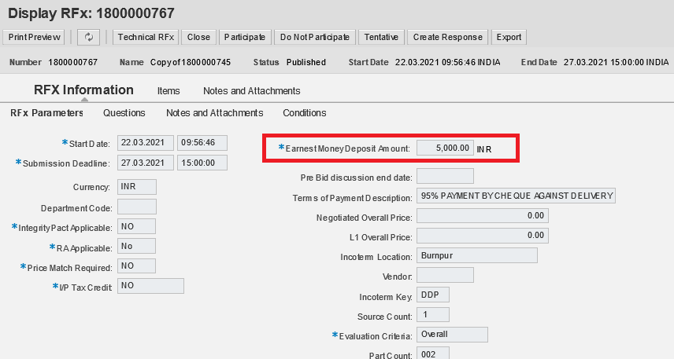
Now after clicking on the create response, new button will appear in quotation screen.
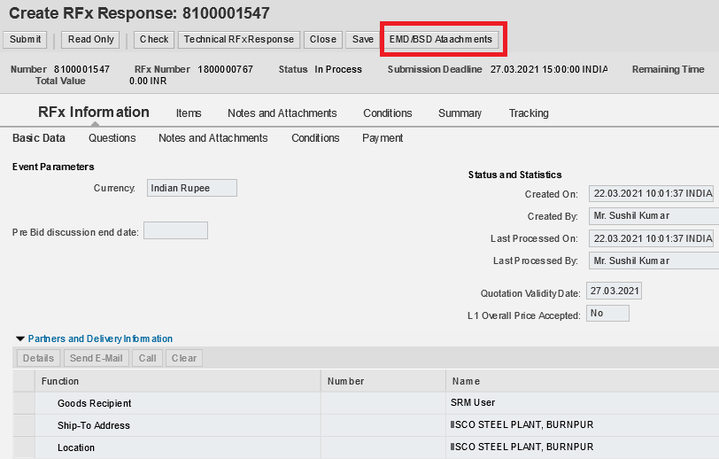
Without submitting, the documents under EMD/BSD Attachments bidder cannot submit his/her quotation.
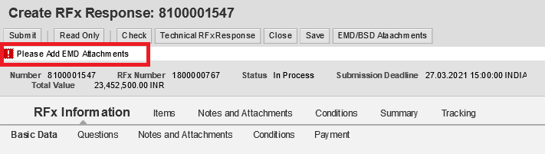
Click on the EMD/BSD Attachments, below window will open.
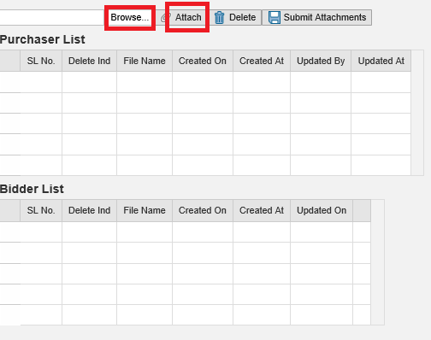

Now click on browse, it will take you to the computer/laptop drive. Select the document and click on open.
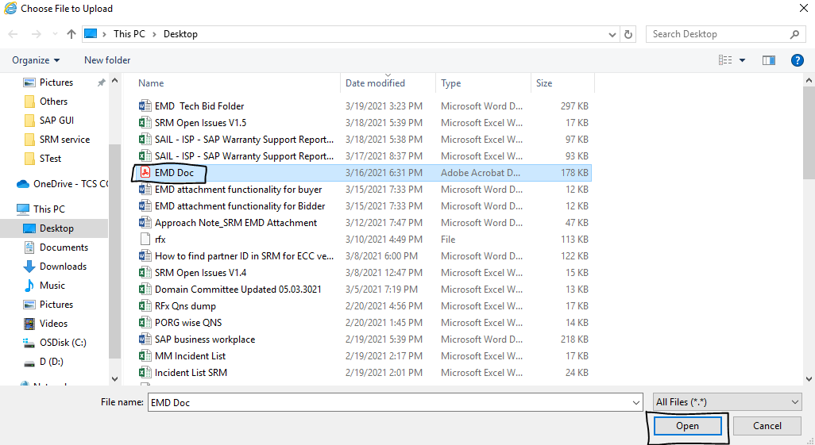
Now click on attach.
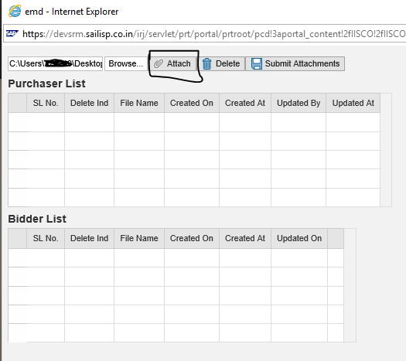
If wrong document is uploaded, then bidder can delete the attachment by selecting the row and clicking on delete.
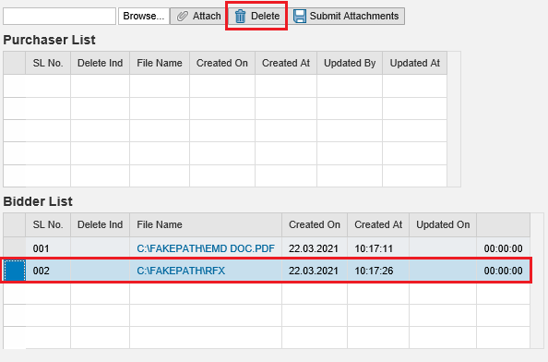
Now click on submit Attachments.
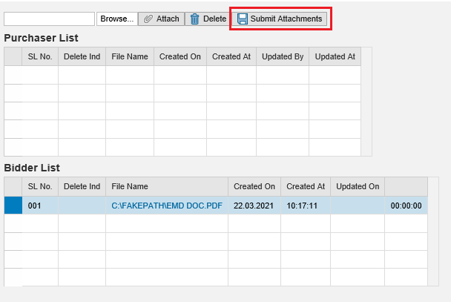
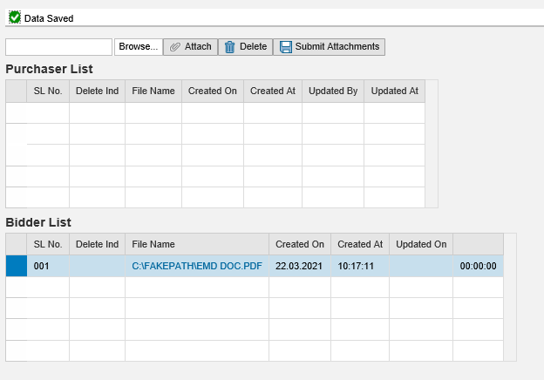
Once attachment is done system will prompt no error, now submit the quotation.
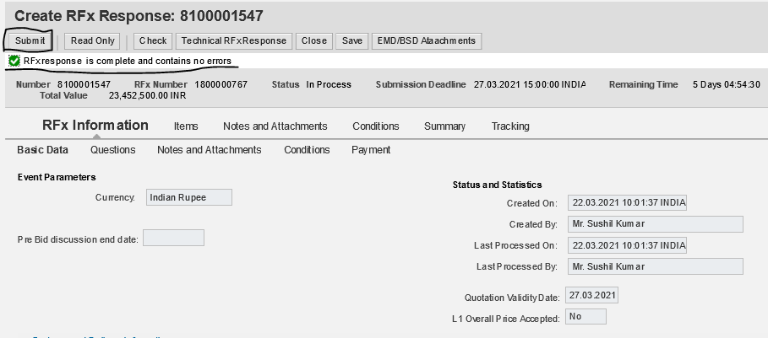

Please Note: If EMD is not applicable for any bidder, then he/she needs to upload the necessary documents under the same.

Bidder will have the access to attach document until submission dead line is over, after that the access will be blocked.
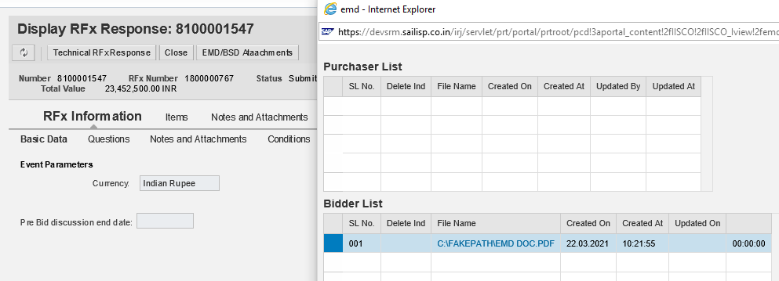

Once EMD opening is done by ISP, then bidder will get access to attach documents depending on ISP’s requirement.
Also bidder can view the documents added by ISP in the purchaser list.
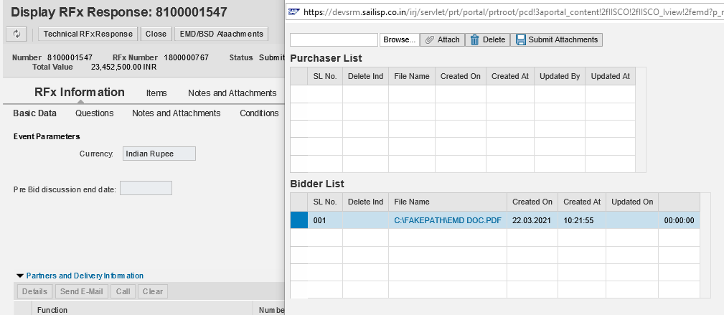

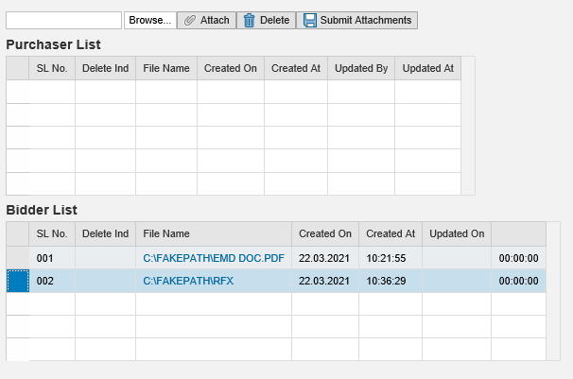

Bidder will have the access until EMD finance vetting, or the EMD is accepted/rejected.
---------------------------------------------------------The End-----------------------------------------------------------------

